Design Language

During our design process, we already decided on our own customized design language, which perfectly suits our app. We collected ideas for an appealing design, which is quite crucial and important for a cooking app. The user should be attracted by the dishes as well as by the app itself and should get a taste for cooking and eating, which is achieved by a fresh and coherent design. Since we didn't want to use a simplistic material design, but also didn't want to stick to iOS in order to make both phone concepts accessible for our app, we decided to use our own design. Nevertheless, our design language takes some aspects from the iOS design, like the app bar or the button design. We are aware that a new, proprietary design language has not been subjected to any testing process. Therefore, extensive usability testing is necessary to ensure the usability and intuitiveness of the app. However, this is an integral part of the User Centred Design process applied here. We perceive the modern and appealing design of our app as a clear advantage and as an USP of our app FOODIYO. In addition, an eye-catching design and an appealing presentation of the dishes were mentioned as user needs in the user interviews.

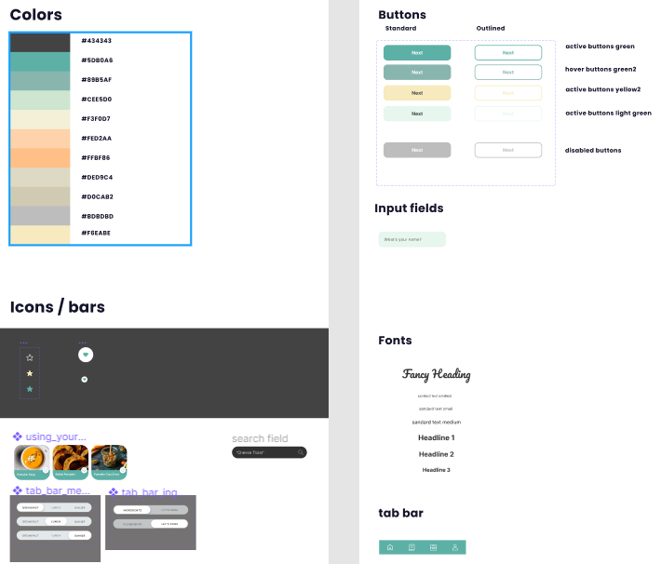

For our color scheme, we used a color palette found on the site: https://colorhunt.co. The colors harmonize very well with each other, and a complementary shade as a highlight color is also available.

Two different fonts are also used in the app. For the title of the app and other special and eye-catching titles or pieces of text, the Google Font *Pacifico* is used, as it fits the style of the app, looks appealing, and can be used for less relevant text passages that are not crucial for the user flow (title of the app etc.). For all other relevant text fields, we use the standard Google Font Inter, each in medium for normal text and bold for headlines.

The following formula was used to calculate the minimum font size: $$h =2 ∙tan{\frac{∝}{2}}d$$

In this case, d represents the distance of the user from the respective font character and α refers to the angle within which the font character is still just readable. After inserting the smallest permissible angle (16 arcminutes) in degrees and the usual reading distance of 400 mm for a cell phone, the following minimum character height h was calculated. Additionally, to determine the value for a character height in the optimal range, we replaced α with the recommended 22 arcminutes in the next step. This gave us a minimum character height of 1.86 mm and a recommended height of 2.55 mm, which we can now consider when designing the prototype. All our used font sizes should meet the requirements of DIN EN ISO 9241-303. According to this, a minimum character height of 16 arcminutes is required and a display with a height of at least 20-22 arcminutes is recommended [1]. In relation to the respective font sizes, this results in a minimum value of 7 pt and a recommended value of 10 pt for Inter and Pacifico.

# Literature:

# [1] DIN EN ISO 9241-303:2012-03: Ergonomie der Mensch-System-Interaktion - Teil 303: Anforderungen an elektronische optische Anzeigen